**Date of the Progress Review**

|  |
| --- |
| 10/11/2023 |

.

**Summary Dashboard**

|  |  |  |  |
| --- | --- | --- | --- |
| **Schedule** **Behind On Ahead** | | **Budget**   **Under On Over** | |
| **80 work complete** |  | **Actual Cost $** |  |
| **20 work remaining** |  | **Remaining Cost $** |  |
|  |  | **Baseline Cost $** |  |
|  |  | **Variance $** |  |

(Record in the dashboard the relevant information to enable accurate reporting of actual performance against both planned work complete (schedule) and planned costs incurred (budget).

Information to go in the summary dashboard can be acquired from MS Project after updating % of tasks completed, and duration / timing of task completion - see: MS Project> Reports> Dashboard> CostOverview )

**Project Progress to date**

Provide a summary of the progress of the project up until the reporting date.

A paragraph of text is required (30-100 words)

**Product Status**

( complete the table below, deleting any functions that are not applicable to your project and list other functions that are within scope for your project)

|  |  |  |  |  |  |
| --- | --- | --- | --- | --- | --- |
| **Functions** | **Proportion of function completed %** | Compliance with IT works coding standards (%) | Compliance with website security requirements (%) | Compliance with website Accessibility requirements (%) | Comments (optional) |
|  |  |  |  |  |  |
|  |  |  |  |  |  |
|  |  |  |  |  |  |
| Server-side: |  |  |  |  |  |
| * Connect to Database | 100% | 100% | 100% | 100% |  |
| * Register | 100% | 100% | 100% | 100% |  |
| * Login | 100% | 100% | 100% | 100% |  |
| * Display products | 100% | 100% | 100% | 100% |  |
| * Search products | 50% | 50% | 0% | 50% | Structure is there but needs to be implemented |
| * Add to cart | 100% | 100% | 100% | 100% |  |
| * View Cart | 20% | 100% | 100% | 100% |  |
| * Remove from cart | 20% | 100% | 100% | 100% |  |
|  |  |  |  |  |  |
|  |  |  |  |  |  |
|  |  |  |  |  |  |
|  |  |  |  |  |  |

**Project Status**

Record relevant information as at the reporting date identifying both the schedule and budget baseline data measured against actual performance and budget to-date. Justify any variations between planned and actual results and the corrective actions (if required).

Another way of looking at “Status” is to tell me “Where are you at!”

Provide a paragraph of text identifying

* current completion status (in front, on track or behind schedule)
* current budget status (below, on or above budget)

(approx. 20 words)

Two screenshots are required

* Insert a screenshot of the Project tasks with % completed from the schedule. You will need to roll up some of the tasks so that the image is not too big
* Insert a screen shot of a costing report for the project.

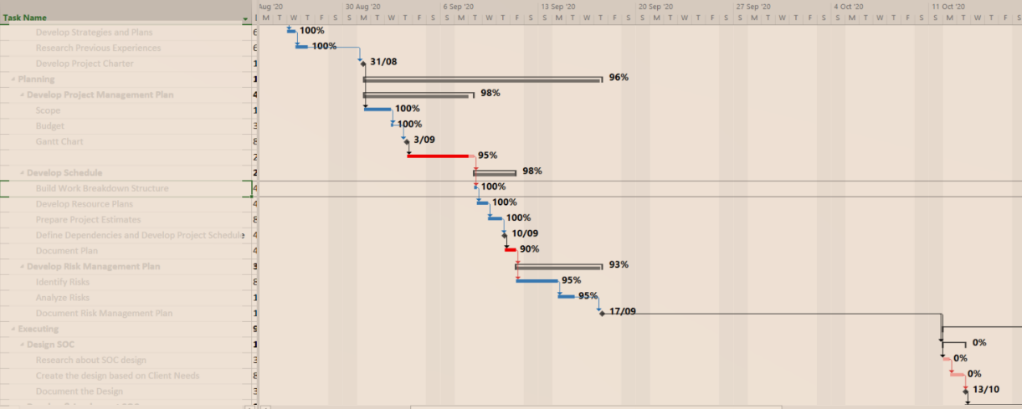

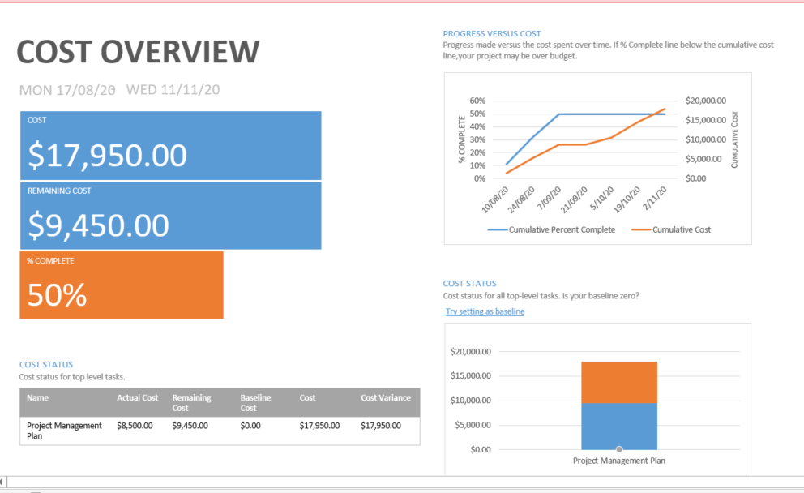

**Risks and Issues**

Update the risk assessment to reflect current risk situation

|  |  |  |  |  |
| --- | --- | --- | --- | --- |
|  | Risk | Status: Active  Dormant  Retired | Risk Monitoring Method | Risk Mitigation or Corrective Action taken during the reporting period [Comment required for active risks] |
| R1 | Project runs behind schedule | Active | Monitored through scheduling tool | Monitor Project Schedule and |
| R2 | Project runs over budget | Active | Monitored through scheduling tool |  |
| R3 | Client's expectations are set too high | Dormant | Monitored through regular client meetings |  |
| R4 | Sponsors / client disengage | Active | Monitored through regular client meetings |  |
| R5 | Unexpected Scope changes | Retired | Monitored through Product Status & Project Change request |  |
| R6 | Team member falls ill / unavailable | Dormant | Monitored through team meetings and team communications |  |
| R7 | Team members leave | Dormant | Monitored through team meetings and team communications |  |
| R8 | Team interaction and performance is below expectations | Dormant | Monitored through team meetings and Product status and scheduling tool |  |

**Completion**

Write a paragraph that reflects on your progress and status, and outlines how you are expecting to complete the project. Reference could include potential risks, contingencies, proposed changes to scope or technology, potential delays and known issues with availability etc.

Basically, Provide a paragraph or more of text identifying the initiatives you expect to employ to complete the project on time and on budget.

Minimum 30 words

**Updates**

Record confirmation the following documents have been amended in line with the Progress report.

* Project Schedule
* Project Change Request

Submission documents for this assessment:

* + Report Template must be used
  + Submissions include:
    - Progress Report
    - An Updated Project Schedule